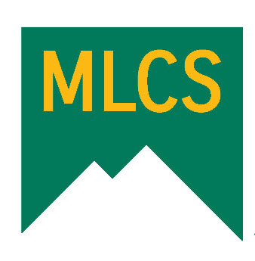
Calendar of Events
Apr/May/Jun 2024

April 2024

April Start CAASPP (State) Testing and MAP Testing

4/18 Picture Day at Pizza Factory 3p to 6p

4/18-19 Alturas Testing

4/25 Farm City Day - 2nd graders (see flyer)
Jensen Hall 9a - 11:30a

May 2024

May Continue and finish CAASPP (State) Testing and MAP Testing

5/1 Turtle Bay/Glowing Wild (see flyer)
See flyer

5/9 5th grade day - Day in the Desert (see flyer)

5/14 Graduation/Promotion Practice - Community Church
12-2

Parent Advisory Council at Round Table
5:30-6:30

5/15 Graduation/Promotion - Community Church
Ceremony starts at 6

5/24 No School - Snow Day

5/27 No School - Memorial Day

5/31 Last Day of School

June 2024

6/7 Sober Graduation at Lassen High Student Center (see flyer)
9:30p - 2a

